# Exercise-1

Create a new web page and create a Form with following form controls.

CODE

<!DOCTYPE html>

<html lang="en">

<head>

<meta charset="UTF-8">

<meta name="viewport" content="width=device-width, initial-scale=1.0">

<title>Radio Button Form</title>

</head>

<body style="height: 70vh; display: flex; justify-content: center; align-items: center;">

<div style="width: 60%; border: 2px solid black; padding: 20px; border-radius: 10px;">

<h1>Search our web site!</h1>

<form id="searchForm" action="#" method="post">

<fieldset>

<h3>Where do you want to search?</h3>

<label for="option1"><input type="radio" id="option1" name="option" value="option1"> Whole site</label><br>

<label for="option2"><input type="radio" id="option2" name="option" value="option2"> Business Partner Section</label><br>

<label for="option3"><input type="radio" id="option3" name="option" value="option3"> Corporate Communication Section</label><br>

<label for="option4"><input type="radio" id="option4" name="option" value="option4"> Lotus Education Section</label><br>

</fieldset>

<h4>Enter a word or two that we can search on:</h4>

<input type="text" id="searchQuery" name="search-query" placeholder="..." style="width: 40vw; height: 2vw;"><br>

<input type="submit" value="Submit" style="margin-top: 20px;">

<button type="button" onclick="clearForm()">Clear</button>

</form>

</div>

<script>

function clearForm() {

document.getElementById("searchForm").reset();

}

</script>

</body>

</html>

OUTPUT

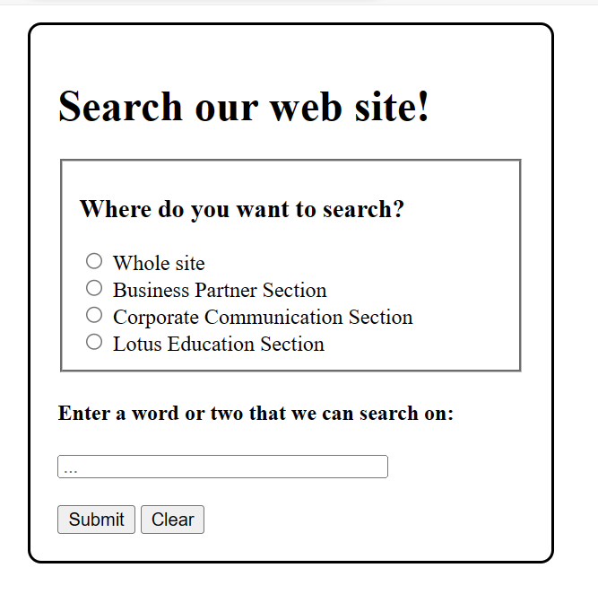

# Exercise 2

Create a new web page and create a Form with following form controls. [ Hint: Make use of TABLE].

CODE

<<!DOCTYPE html>

<html>

<head>

<meta charset="utf-8">

<meta name="viewport" content="width=device-width, initial-scale=1">

<title></title>

</head>

<body>

<table border="0">

<tr>

<td><h2>HTML Form Test</h2></td>

</tr>

<form name="fome1" form action="URL" method="get">

<tr>

<td>Name</td>

<td><input type="text" name="Name"></td>

</tr>

<tr>

<td>Address</td>

<td><input type="text" name="Address"></td>

</tr>

<tr>

<td>Email</td>

<td><input type="text" name="Email"></td>

</tr>

<tr>

<td>Gender</td>

<td><input type="Radio" id="male" name="gender" value="Male"checked>Male

<input type="Radio" id="male" name="gender" value="Female">Female</td>

</tr>

<tr>

<td>Hobbies</td>

<td><input type="checkbox" name="hobbies" id="hobbies 1" values="hobbies 1"><label>Sports</label>

<input type="checkbox" name="hobbies" id="hobbies 2" values="hobbies 2"><label>Movies</label>

<input type="checkbox" name="hobbies" id="hobbies 3" values="hobbies 3"><label>Travelling</label>

</td>

</tr>

<tr>

<td>

<label>Country</label>

</td>

<td>

<Select name="Country">

<option value="C1">Nepal</option>

<option value="C2">China</option>

<option value="C3">India</option>

<option value="C4">Bhutan</option>

</Select>

</td>

</tr>

<tr>

<td>Message</td>

<td>

<textarea name="Message" id="Message" cols="30" rows="10"></textarea>

</td>

</tr>

<tr>

<td>

<input type="submit" value="Submit">

<input type="reset" value="Reset">

</td>

</tr>

</form>

</table>

</body>

</html>

OUTPUT

